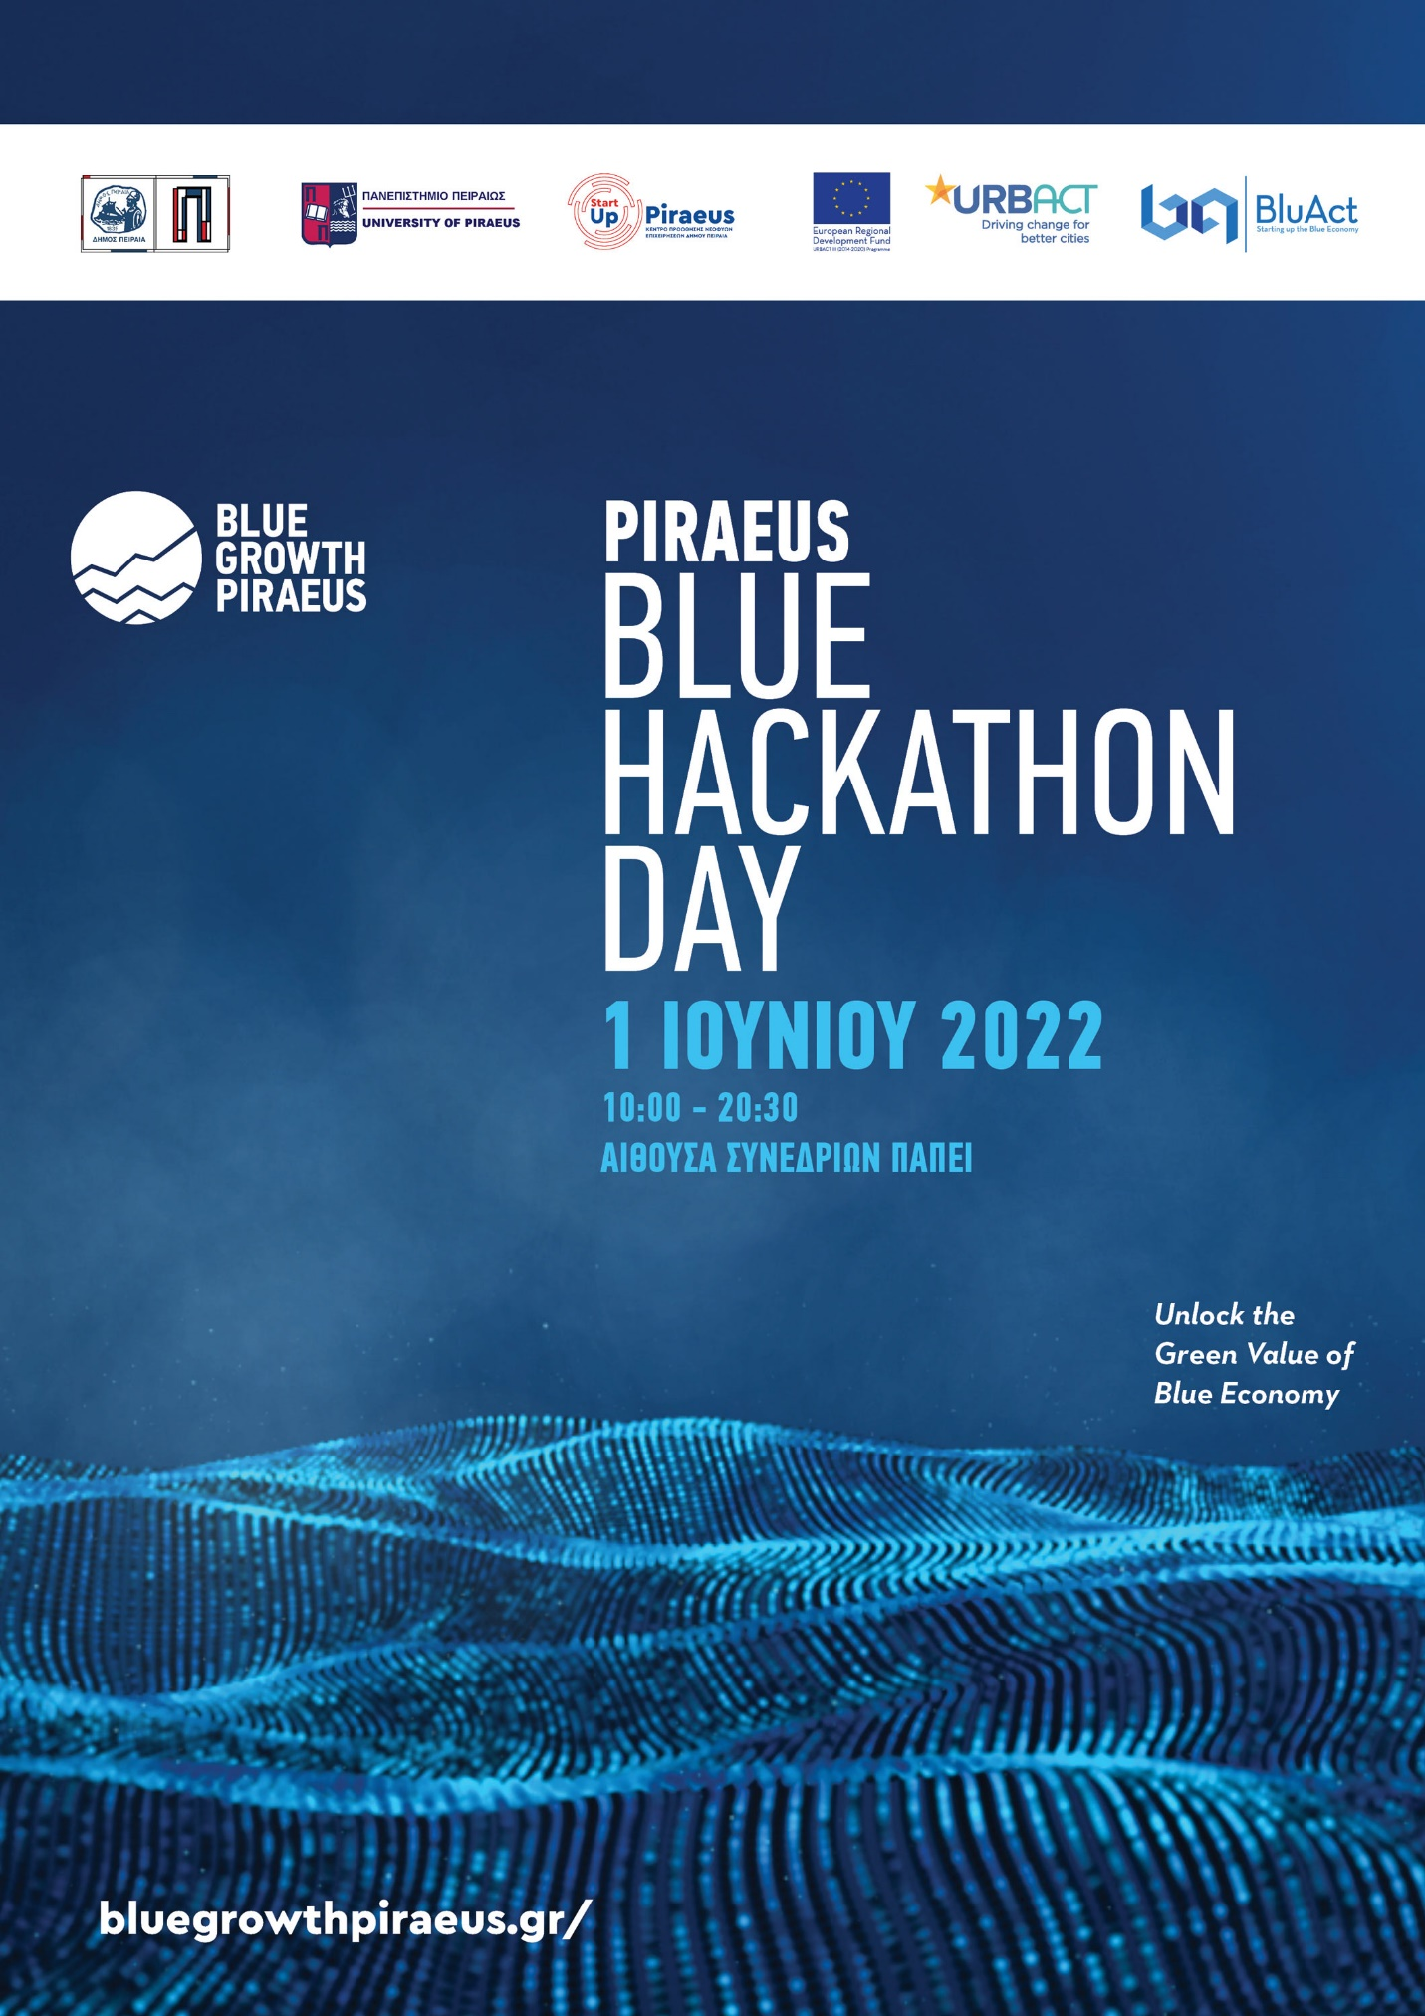
Στοιχεία Μέντορα Blue Hackathon:

Ονοματεπώνυμο : Σταματία Γιασιράνη

Στοιχεία Επικοινωνίας : Κάντε κλικ ή πατήστε εδώ για να εισαγάγετε κείμενο.
Ε-mail: stamatinagias@gmail.com
Tηλέφωνο: 6944702559

Τίτλος/θέση εργασία και φορέα: Project Development Manager WIMA

Ειδίκευση: Κάντε κλικ ή πατήστε εδώ για να εισαγάγετε κείμενο.

Συνοπτική Παρουσίαση έργου:
Stamatia Giasirani holds the position of Project Development Manager of WIMA Association. She holds a degree of Political Science and Social Policy of Panteion University of Social and Political Sciences of Athens. She is a serial project manager and business developer for the last 8 years. Since her first position in the Public sector up to the latest position in Bluegrowth, she has managed to accomplish highly complex and demanding projects, on both operating and developing perspectives.
Her career began during her studies at Ministry of Justice, Transparency and Human Rights in Court of Auditors. Worked in Ministry of Education, Research and Religious Affairs when she finished her studies. She moved to Science View Company, as Junior Marketing Manager where she was responsible for international scientific conferences. After she moved to Trade.com a company of Lead Capital Markets as Account Manager. In 2015 she moved to Aephoria.net. As a team member of Aephoria.net organization, she has taken part in many vertical-sector projects such as Viti Vini Lab, Olive Challenge contests, gaining experience and evolving her skills with a 360’ approach on how to initiate, schedule and execute of such national projects. Moreover as Project Manager of Bluegrowth Greece, she has gained extended experience in the Blue Economy sector, achieving for 5 years the Organisation’s operation and
development with great results. In 2021 she moved to her current position where she still works.

Φωτογραφία:

Linkedin Profile url: https://www.linkedin.com/feed/

Ευχαριστούμε για τη συμμετοχή σας!!!
Για περισσότερες πληροφορίες μπορείτε να επικοινωνήσετε μαζί μας στο: 6970149858 και στο bluegrowthpir@gmail.com.

